**UNDERSTANDING THE TOURISM ENVIRONMENT AND ITS STAKEHOLDERS IN CANADA**

**Table of Contents**

Introduction 3

Paragraph 1 3

Paragraph 2 6

Paragraph 3 8

Paragraph 4 10

Conclusion 11

Reference List 13

# Introduction

Essay will investigate tourism industry research in Canada, attracting millions of visitors each year. However, tourism also has the potential to negatively impact the environment, local communities, and cultures. Sustainable tourism is a concept that seeks to balance economic, social, and environmental concerns in tourism development. The goal of sustainable tourism is to maximize the positive impacts of tourism while minimizing the negative ones.

The purpose of this essay is to investigate the notion of sustainable tourism & its foundations for developing sustainable tourism in Canada. It will investigate the role of stakeholders throughout the process of making choices of promoting sustainable tourism, along with the macro-environmental variables that contribute to Canada's long-term sustainability. Following that, it will examine the economic microenvironment as well as the motivational factors for travelers that drive interest in Canadian tourism products.

The tourism industry in Canada must continue to evolve sustainably, taking into account the impact on the environment and local communities. Governments, tourist operators, as well as community members are among the stakeholders that engage in the process of making choices for sustainable tourism development. They must work together to strike a balance between economic, social, and environmental considerations. By doing so, the industry can achieve sustainable growth and continue to provide economic benefits to Canada's communities and businesses.

# Paragraph 1

**Definition of Sustainable Tourism**

Sustainable tourism is a tourism concept that tries to enhance a tourist's financial, social, as well as environmental advantages whilst reducing its adverse effects (Dimitrovski *et al.* 2021). Sustainable tourism has been described as "an industry that takes into consideration all of its present as well as potential economic, societal, & ecological impacts, meeting the requirements of tourists, the tourism sector, the natural world, as well as host neighborhoods," as stated by the "United Nations World Tourism Organization'' (UNWTO).

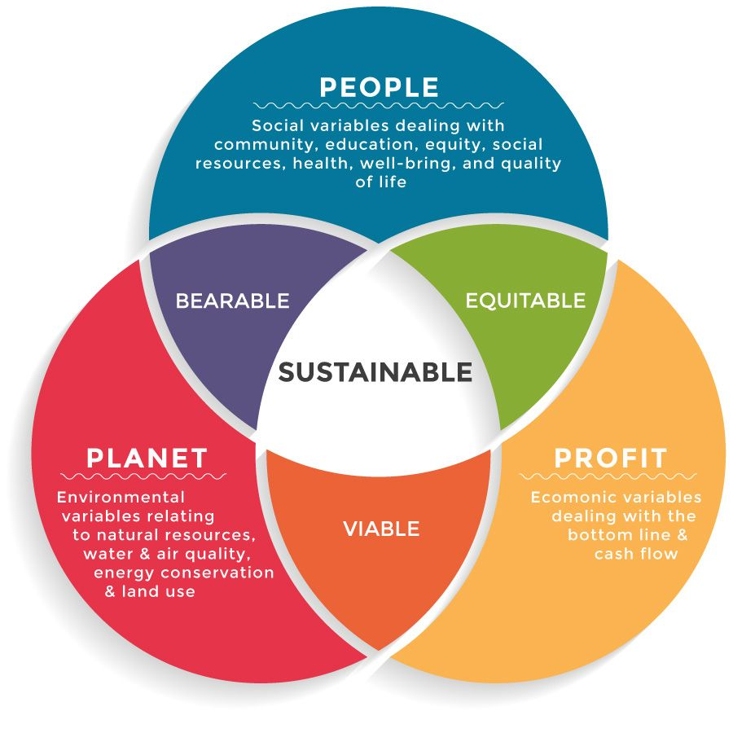

**Figure 1: Sustainable Tourism**

(Source: https://upskill.study/sustainable-tourism)

**Rationales Behind Sustainable Tourism**

Sustainable tourism encourages the preservation of natural as well as cultural resources while minimizing the adverse ecological effect of tourism operations. It has the potential to assist local communities by fostering local employment and creating cash for local companies (Edge *et al.* 2020). This also has the ability for producing possibilities for all people in the community while also promoting social fairness and decreasing poverty. Sustainable tourism marketing can result in a more equitable as well as sustainable tourism business that benefits not just visitors but also local people and the environment.

**Importance of Sustainable Approach for Decision Makers**

Decision-makers play a critical role in promoting sustainable tourism in Canada. By adopting a sustainable approach, decision-makers can ensure that the benefits of tourism are maximized while minimizing the negative impacts (Grimwood *et al.* 2019). This can help to promote economic development, protect the environment, and preserve cultural heritage, among other benefits.

**Examples of Successful Application of Sustainable Principles in Canada**

**Tofino, British Columbia:** Tofino is a popular tourist destination located on the west coast of Vancouver Island. The town has taken a sustainable approach to tourism, promoting environmental protection, cultural preservation, and social equity (Hazel and Mason, 2020). The local government has implemented measures to reduce the negative impact of tourism on the environment, including restrictions on development and the promotion of sustainable tourism activities such as hiking and whale watching. As a result, Tofino has become a model for sustainable tourism in Canada, attracting visitors who are interested in eco-friendly and socially responsible travel.

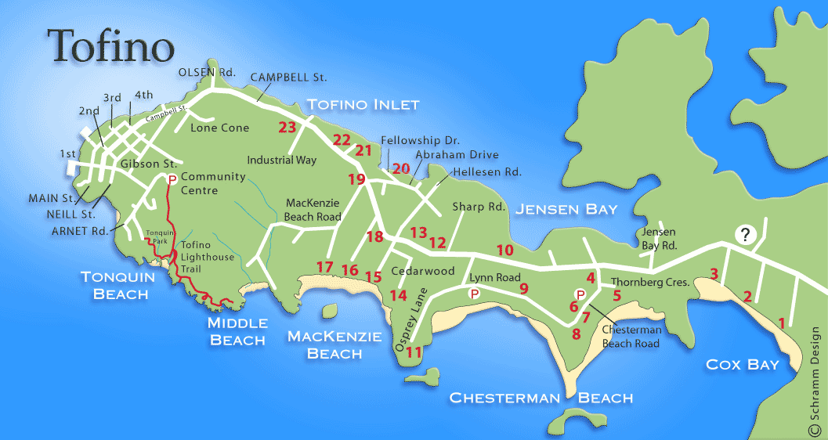

**Figure 2: Tofino**

(Source: https://www.longbeachmaps.com/tofino.html)

**Niagara-on-the-Lake, Ontario:** Niagara-on-the-Lake is a historic town located in the Niagara Region of Ontario. The town has a rich cultural heritage and has taken steps to preserve its historic buildings, promoting cultural tourism (Grimwood *et al.* 2019). The town has also implemented sustainable tourism practices, such as the promotion of local food and wine, the use of green energy, and the reduction of waste. As a result, ***Niagara-on-the-Lake*** has become a popular destination for cultural and sustainable tourism, attracting visitors who are interested in history, culture, and sustainable living.



**Figure 2: Niagara-on-the-Lake**

(Source: https://www.ontarioaway.com/things-to-do-in-niagara-on-the-lake/)

**Benefits of Sustainable Tourism for Canada:**

Sustainable tourism can provide economic benefits to local communities, generating revenue for local businesses and promoting employment (Guo *et al.* 2019). It could promote the protection of natural resources and reduce the negative impact of tourism on the environment. This also may help to preserve cultural heritage, traditions, and practices, promoting cultural diversity and community involvement.

# Paragraph 2

In Canada, the tourism industry is a significant contributor to the country's economy, with an estimated $105 billion in revenue and employing 1.8 million people. As such, various stakeholders play a crucial role in decision-making and shaping the tourism environment in the country.

**Public sector**

The public sector, particularly the federal and provincial governments, is one of the major stakeholders in the Canadian tourism industry. The government plays a critical role in developing and implementing policies, regulations, and funding initiatives that support the industry's growth and sustainability (James *et al.* 2020). For instance, the Canadian government launched the ***Canadian Experience Class***, a program that facilitates the immigration of skilled workers to the country, with a focus on attracting those who could contribute to the tourism industry. Additionally, the government launched the ***Tourism Relief Fund in 2021***, which provided financial support to eligible tourism businesses affected by the COVID-19 pandemic. The government's role in tourism is vital as it helps to create a favorable business environment, attract investment, and promote tourism both domestically and internationally.

**Private sector**

The private sector is another essential stakeholder in the Canadian tourism industry. Private businesses, including ***hotels, restaurants, tour operators, and transport companies***, play a significant role in providing services and products to tourists. The private sector's involvement in the tourism industry is critical as it drives innovation, job creation, and economic growth (Johnston *et al.* 2019). For instance, many Canadian businesses have adopted smart technology to enhance their operations, such as ***implementing online booking systems*** and ***contactless payment methods***. The private sector's participation in the industry also contributes to the country's competitiveness as a tourism destination.

**Figure 4: Different Stakeholders**

(Source: Self-created)

**Host community**

The host community has been another critical stakeholder in the Canadian tourism industry. Communities play an essential role in providing hospitality and creating authentic experiences for tourists. Involving the host community in tourism development can help to ensure that the benefits of tourism are distributed fairly and sustainably. Engaging local communities in tourism planning can help to mitigate any negative impacts that tourism may have on the environment, culture, and society (Schweinsberg *et al.* 2021). For example, the ***Indigenous Tourism Association of Canada*** works to promote Indigenous tourism in Canada while respecting and celebrating Indigenous cultures and traditions.

The Canadian tourism industry involves a range of stakeholders with different roles and interests. The public sector, private sector, and host community are among the most critical stakeholders in the industry (Roxas *et al.* 2020). The Canadian government's support, private businesses' innovation, and the host community's involvement are all essential for the industry's growth and sustainability. Understanding the importance and interests of each stakeholder can help to ensure that tourism development in Canada is responsible, sustainable, and beneficial to all parties involved.

# Paragraph 3

**Environmental trends**

Environmental trends are one of the major elements affecting the growth of green tourism in Canada. The changing climate remains a key environmental concern for Canada's tourism economy. Rising icebergs, increasing sea levels, as well as more frequent severe thunderstorms endanger Canada's ecosystems as well as biodiversity, which attract tourists. In response, the Canadian government has implemented various policies to promote sustainability in the tourism industry, such as the "Sustainable Tourism Assessment and Rating System" (STARS) and Canada's National Strategy on Climate Change and Clean Growth (Rutty *et al.* 2020). These policies encourage tourism stakeholders to adopt environmentally sustainable practices, reducing their carbon footprint and promoting responsible use of natural resources. However, the cost of implementing these policies may be high, which could discourage investment and development in the tourism industry.

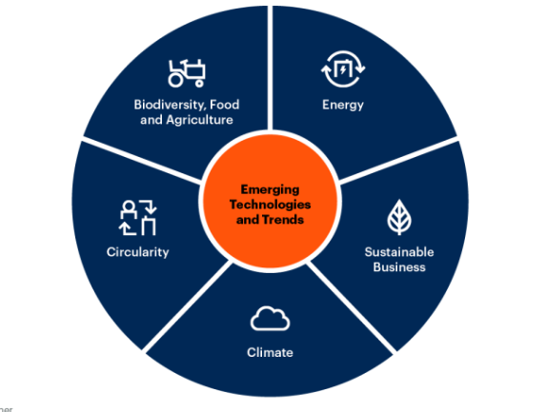

**Figure 5: Environmental Sustainability**

(Source: kerlink.com)

**Cultural trends**

In the case of cultural trends, the rise of the ***millennial market*** and their desire for personalized and authentic experiences has resulted in the growth of ***niche tourism markets***, such as culinary tourism, cultural tourism, and adventure tourism. This presents an opportunity for Canada to showcase its diverse cultural heritage and natural wonders (Schweinsberg *et al.* 2021). However, it also requires a delicate balance between meeting the demands of tourists and preserving the cultural and social integrity of the host community. For example, the ***over-commercialization*** of cultural events and sites may lead to cultural homogenization and loss of authenticity, which could ultimately harm the long-term sustainability of the tourism industry.

**Economic trends**

Lastly, economic trends such as boom and recession periods have a significant impact on the growth of sustainable tourism within Canada. During boom periods, tourism stakeholders may prioritize short-term gains over long-term sustainability, leading to overdevelopment and environmental degradation. Conversely, during recession periods, tourism may decline, resulting in reduced revenue and job losses (Weber *et al.* 2019). To mitigate these impacts, the Canadian government has implemented policies to support the tourism industry during economic downturns, such as the Tourism Industry Association of Canada's COVID-19 Recovery Plan, which aims to provide financial assistance and support to tourism businesses affected by the pandemic.

Environmental, social and cultural, and economic trends are macro factors that significantly influence the development of sustainable tourism in Canada. By recognizing these factors and implementing policies and practices that promote sustainability, the Canadian tourism industry can continue to thrive while preserving the natural and cultural heritage that makes it unique.

# Paragraph 4

Experiencing micro factors are the crucial aspect of Canada's tourism economy, generating significant revenue and employment opportunities. Several micro features influence the need for travel in Canada are listed below,

**Internal elements of motivation**

As an inherent single visitor, it is one of the micro variables impacting demand for tourist attractions in Canada. Tourists have distinct requirements that inspire people to travel, following Maslow's hierarchy of requirements. For instance, certain visitors might head to Canada to meet physiological requirements such as shelter, food, and water, whilst others may go for ambitions such as development along with realization (Schweinsberg *et al.* 2021). Furthermore, intrinsic incentives like enjoyment, and assurance, as well as psychological requirements such as self-realization & social needs may motivate tourist motives.

Canada offers a wide range of experiences and attractions that cater to various tourist motivations, including natural wonders, cultural and historical sites, and adventure activities.

**Tourists' perceptions**

Another micro factor is tourists' perceptions of the destination where tourists' beliefs, values, and attitudes towards a destination can significantly influence their decision to travel there (Scott *et al.* 2020). Positive perceptions of Canada as a safe, welcoming, and diverse country with natural beauty, rich cultural heritage, and high-quality tourist services can attract tourists from all over the world. In contrast, negative perceptions of Canada as a cold, expensive, and distant destination may discourage tourists from traveling to the country.

**Figure 6: Tṣourists' perceptions**

(Source: Self-created)

**Intrinsic characteristics**

Intrinsic characteristics such as personality as well as travel location preferences also impact tourism demand in Canada. Allocentric travelers tend to be cautious as well as want familiar and regular situations, whereas psychologically focused tourists are generally more cautious as well as prefer recognizable & regular encounters (Schweinsberg *et al.* 2021). From outdoor adventure sports like riding a snowboard or skiing to historical sites like galleries as well as celebrations, Canada caters to both sorts of travelers.

**Extrinsic motivators**

Finally, extrinsic motivators such as cash, economic income, geography, relatives, as well as age impact tourist demand in Canada. Visitors with greater discretionary incomes, for instance, might be inclined to visit Canada because of its image as a high-end location, but visitors with fewer resources could be put off by the nation's expensive cost of living. Similarly, tourists' social class, location, family status, and age can influence their decision to travel to Canada.

# Conclusion

Sustainable tourism is an essential concept that must be implemented to ensure that the tourism industry in Canada can continue to thrive while minimizing its negative impacts. This essay has looked at the fundamentals of sustainable tourism growth within Canada, the significance of stakeholders in making decisions, macro-environmental variables that contribute to environmentally friendly growth, as well as the highly competitive micro-environment as well as visitors' motivators that influence consumer interest in Canadian tourist attractions.ṣ

It has been found that sustainable tourism development in Canada requires collaboration among stakeholders to balance economic, social, and environmental concerns. Governments must implement policies and regulations that promote sustainable practices in the industry. Tourism operators must adopt sustainable practices that reduce their impact on the environment and support local communities. Local communities must be involved in the decision-making process and benefit from the economic opportunities created by tourism.

To enhance the competitiveness of Canadian tourism products, the industry must continue to adapt to changing consumer demands and preferences. Incentives for eco-tourism, adventure tourism, and cultural tourism can help attract tourists who are seeking unique and authentic experiences. By working together to promote sustainable practices and adapting to changing consumer demands, the industry can continue to provide economic benefits while preserving Canada's natural and cultural resources for future generations.

# Reference List

**Journals**

Dimitrovski, D., Lemmetyinen, A., Nieminen, L. and Pohjola, T., 2021. Understanding coastal and marine tourism sustainability-A multi-stakeholder analysis. *Journal of Destination Marketing & Management*, *19*, p.100554.

Edge, S., Goodfield, J. and Dean, J., 2020. Shifting gears on sustainable transport transitions: Stakeholder perspectives on e-bikes in Toronto, Canada. *Environmental Innovation and Societal Transitions*, *36*, pp.197-208.

Grimwood, B.S., Muldoon, M.L. and Stevens, Z.M., 2019. Settler colonialism, Indigenous cultures, and the promotional landscape of tourism in Ontario, Canada's ‘near North’. *Journal of Heritage Tourism*, *14*(3), pp.233-248.

Guo, Y., Jiang, J. and Li, S., 2019. A sustainable tourism policy research review. *Sustainability*, *11*(11), p.3187.

Hazel, D. and Mason, C., 2020. The role of stakeholders in shifting environmental practices of music festivals in British Columbia, Canada. *International Journal of Event and Festival Management*, *11*(2), pp.181-202.

James, L., Olsen, L.S. and Karlsdóttir, A., 2020. Sustainability and cruise tourism in the arctic: Stakeholder perspectives from Ísafjörður, Iceland and Qaqortoq, Greenland. *Journal of Sustainable Tourism*, *28*(9), pp.1425-1441.

Johnston, M., Dawson, J. and Stewart, E., 2019. Marine tourism in Nunavut: Issues and opportunities for economic development in Arctic Canada. *Perspectives on rural tourism geographies: Case studies from developed nations on the exotic, the fringe and the boring bits in between*, pp.115-136.

Roxas, F.M.Y., Rivera, J.P.R. and Gutierrez, E.L.M., 2020. Mapping stakeholders’ roles in governing sustainable tourism destinations. *Journal of Hospitality and Tourism Management*, *45*, pp.387-398.

Rutty, M., Scott, D., Matthews, L., Burrowes, R., Trotman, A., Mahon, R. and Charles, A., 2020. An inter-comparison of the holiday climate index (HCI: Beach) and the tourism climate index (TCI) to explain Canadian tourism arrivals to the Caribbean. *Atmosphere*, *11*(4), p.412.

Schweinsberg, S., Wearing, S. and Lai, P.H., 2021. Host communities and last chance tourism. *Tourism Geographies*, *23*(5-6), pp.945-962.

Scott, D., Steiger, R., Knowles, N. and Fang, Y., 2020. Regional ski tourism risk to climate change: An inter-comparison of Eastern Canada and US Northeast markets. *Journal of Sustainable Tourism*, *28*(4), pp.568-586.

Weber, M., Groulx, M., Lemieux, C.J., Scott, D. and Dawson, J., 2019. Balancing the dual mandate of conservation and visitor use at a Canadian world heritage site in an era of rapid climate change. *Journal of Sustainable Tourism*.